Writing Sample: Cyberbullying Curriculum

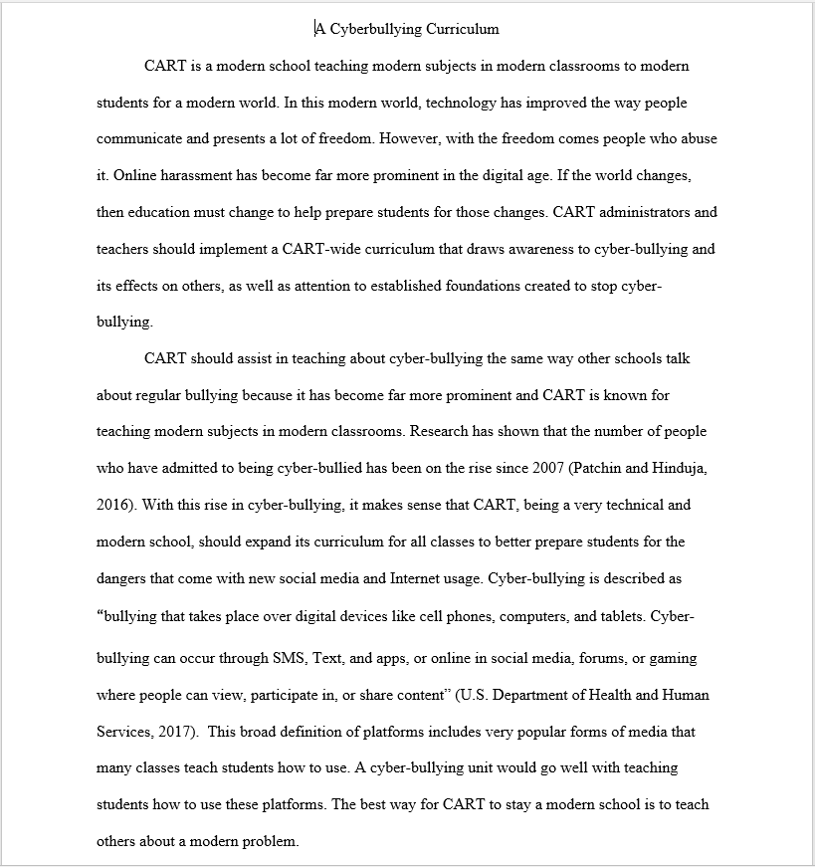

This is the first page of an essay I wrote for the web application development lab, formatted in MLA. It is an argumentative essay that attempts to convince administrators to implement a CART-wide curriculum on cyberbullying. I chose this essay because it was one of my best-written essays to date. Not only did I score high when it was graded, I felt my arguments were very strong and everything flowed well together.